Relevance of Health Literacy to ADRCs
Prepared by Carolime Kuo

Background

Introduction
The National Library of Medicine defines health literacy as “the degree to which people can obtain, process, and understand basic health information and services they need to make appropriate health decisions.” Awareness among health care providers, plans, payers, public health agencies and other stakeholders that people with low health literacy skills face difficulties accessing and navigating the health care system or understanding information about their health, conditions, treatment options and coverage has prompted greater emphasis in the health care field on making communications with patients clear and easy-to-read.
Aging and Disability Resource Center (ADRC) staff must understand health literacy in order to conduct successful outreach to ADRC target audiences, provide culturally competent care, and gain community trust. Even though ADRCs generally do not provide health care services, they function as a crucial link between consumers and direct health care services by improving access to information about long term care options and assisting consumers to navigate the health and human service systems through information, assistance, and referral to long term care resources. Provision of information, assistance, and referral in a manner sensitive to consumer literacy levels helps ensure individuals can understand ADRC brochures, Web sites, counselors, and other types of materials in order to take full advantage of ADRC resources and services. In addition, ADRCs’ attention to health literacy and the broader topic of literacy can result in more successful outreach and marketing, particularly for older adults and Medicaid recipients, who have lower than average literacy rates.

Prevalence of Low Literacy
According to the 1993 National Assessment of Adult Literacy, the largest assessment of adult literacy funded by the Federal government to date, the average adult in the U.S. reads between the 8th and 9th grade reading levels.
Literacy levels are lower among older adults. The survey found that the average adult age 60 or older had a literacy level of level 1 or level 2, reading at the 8th or 9th grade level. This means that many of the older adults that ADRCs serve may have trouble with comprehension of language, finding or processing quantitative information, filling out forms, following directions, and reading schedules. In addition, these older adults who scored poorly on literacy tests perceived that they did not need assistance or have a problem with accomplishing literary task.
ADRCs also serve individuals with limited incomes who may be Medicaid beneficiaries. The survey revealed a strong association between economic status and literacy; between 41 and 44 percent of individuals who scored lowest in literacy tests were in poverty. Further, the percentage of older adults in lower income categories increases with age and older adults with lower incomes scored lower in literacy proficiencies when compared with their counterparts who have higher incomes.

Recommended Actions for ADRCs
The data clearly suggest that ADRCs must seriously consider how literacy and health literacy affect interactions with consumers, particularly in light of low literacy levels in ADRC target populations.
ADRCs play a crucial role in actively helping consumers with low literacy levels in gaining the long term care resources that they need. In many cases, ADRC staff may be the sole source of information for individuals with low literacy levels who are unable to understand written long term care resources. Thus, in addition to ensuring that written materials are clear and accessible to consumers with lower literacy levels, ADRCs should not assume that consumers can read and understand information and should routinely offer assistance with interpreting and or explaining information. In addition, ADRCs should write materials at the eighth grade reading level or lower.
This brief is written at a twelfth grade level.
The Fry Graph (Appendix A) is a simple tool that ADRCs can use to assess the grade level of written materials. Table 1 includes examples of text at various reading levels. These examples of text are used to explain the concept of voluntary participation in a study.
Table 1: Examples of Text Written at Various Reading Levels
Reading Level | Text
4th Grade | “You don’t have to be in this research study. You can agree to be in the study now and change your mind later. Your decision will not affect your regular care. Your doctor’s attitude toward you will not change.”
6th Grade | “Taking part in this study is your choice. If you decide not to take part, this will not harm your relations with your doctors or with the University.”
8th Grade | “Participation in this study is entirely voluntary. You have the right to leave the study at any time. Leaving the study will not result in any penalty or loss of benefits to which you are entitled.”
10th Grade | “Your participation in this study is voluntary and you are free to withdraw at any time. Participation or withdrawal will not affect any rights to which you are entitled.”
12th Grade | “Your participation in this study is strictly voluntary. You have the right to choose not to participate or to withdraw your participation at any point in this study without prejudice to your future health care or other services to which you are otherwise entitled.”
College | “You voluntarily consent to participate in this research investigation. You may refuse to participate in this investigation or withdraw your consent and discontinue participation in this study without penalty and without affecting your future care or your ability to receive alternative medical treatment at the University.”

In addition to keeping the grade level of written materials at a reasonable level, Table 2 provides several action steps ADRCs can take to overcome literacy barriers.
Table 2: Recommended ADRC Actions Steps to Address Health Literacy
Key Work Areas | Literacy Levels and ADRC Action Items
ADRC Service Components
Outreach and Marketing | - In requests for proposals, ask marketing vendors to discuss their capacity around health literacy and how they will ensure that materials are accessible to people with lower reading levels;  - Design outreach and marketing materials paying particular attention to appropriate use of language, visuals, graphs, and tables; and  - Assess the readability of materials using the Fry Graph or literacy experts.
Information and Referral/ LTC Counseling/ Eligibility Determination | - Train all staff members who work with consumers on literacy issues;  - Use simple language when speaking to consumers;  - Listening actively to consumers;  - Ensure that all information and referral resources (e.g., resource brochures, public resource directories and listings) are written at an appropriate level of comprehension for ADRC target populations;  - Ensure that all forms and applications for services are written at an appropriate level of comprehension for ADRC target populations;  - Actively support referrals by helping clients get services they need (versus simply providing clients with phone numbers); and  - Help consumers understand basic long-term care issues such as Medicare coverage versus Medicaid by explaining these issues in multiple ways – through visuals, written resources, and by speaking.
Stakeholder Input and Partnerships
Consumer Involvement | - Maximize consumer involvement by soliciting input and advice at an appropriate level of comprehension; and  - Utilize consumers on advisory groups as beta test groups to screen written materials and Web site content.
IT and MIS
Web site Development | - In requests for proposals, ask Web designers to discuss their capacity around health literacy;  - Work with Web designers and content managers to ensure that Web site content meets appropriate levels of comprehension.
Evaluation
Customer Satisfaction | - Work with project evaluator to design consumer feedback surveys at an appropriate level of comprehension for ADRC target populations; and  - Encourage project evaluator to measure test/re-test reliability of survey questions and check survey content validity using small sample of consumers or through focus groups.

Resources

Pfizer Clear Health Communication Initiative (http://www.pfizerhealthliteracy.com/improving.html)
Pfizer summarizes principles for clear health communication and includes several resources on health literacy including a prevalence of low literacy calculator, the Fry test, and a patient education handbook on literacy.

California Health Literacy Initiative (http://www.cahealthliteracy.org/healthliteracyresourcecenter.html)
The California Health Literacy Organization provides a one-stop Health Literacy Resource Center on the Web. The page includes resources on designing accessible materials, literacy experts, health literacy policy and models, and publications.

Harvard School of Public Health – Health Literacy Studies (http://www.hsph.harvard.edu/healthliteracy/)
The Harvard School of Public Health provides a comprehensive list of resources on health literacy including definitions, literature, resources on creating and assessing print materials, etc.

US Health Resources and Services Administration (http://www.hrsa.gov/quality/healthlit.htm)
One focus of the US Health Resources and Services Administration is on improving health literacy as part of the Healthy People 2010 goals. The site includes links to other Web sites focusing on health literacy.

Appendix A. Fry Readability Chart and Instructions
Readability Testing. It is fairly easy to check the grade level of written materials using the Fry readability formula. ADRC consumer materials should be designed at the 6th to 8th grade reading levels. Grade level is determined by the number of words per sentence and the number of syllables per word. The more words per sentence and the more syllables per word, the higher the grade level. For more detailed instructions on using the Fry Formula, go to:
http://www.pfizerhealthliteracy.com/TheFryTestingReadabilityFormula.pdf.
Instructions for Using the Fry Graph:
- Count out three 100-word passages in your document (use passages from different sections if possible).
- Count the number of syllables in each 100-word passage.
- Count the number of sentences in each 100-word passage.
- Calculate the average number of syllables per passage and the average number of sentences per passage.
- Where those intersect on the chart is the approximate grade level of the material.
For further assistance with assessing the grade level of a document, please contact the TAE at
adrc-tae@lewin.com.

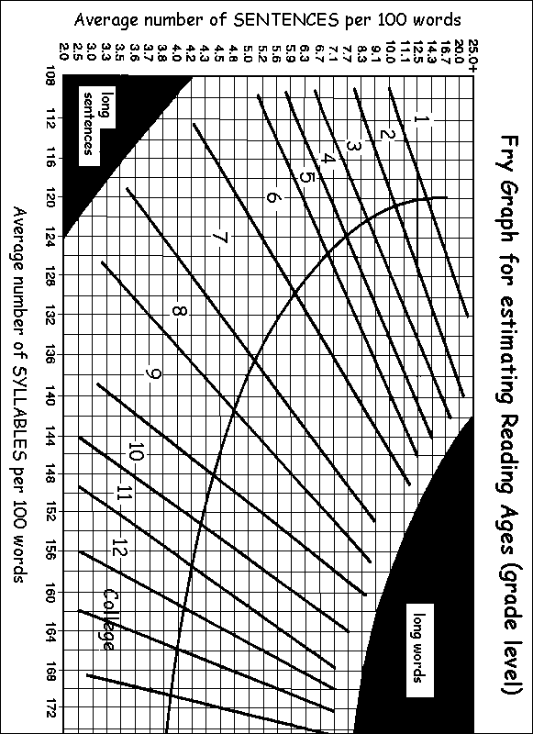

Accessed on June 20, 2005. http://www.healthliteracy.com/oncallsep2000.html.
Accessed on June 21, 2005. http://www.pfizerhealthliteracy.com/pdfs/The_Health_Literacy_Problem_v2.pdf. Cited from Kirsch IS, Jungeblut A, Jenkins L, Kolstad A. Adult Literacy in America. National Center for Education Statistics, U. S. Department of Education, September, 1993, Washington,D.C.
Accessed on June 21, 2005. http://www.pfizerhealthliteracy.com/pdfs/The_Health_Literacy_Problem_v2.pdf and http://nces.ed.gov/pubs97/97576.pdf.
Accessed on June 16, 2005. http://nces.ed.gov/pubs97/97576.pdfand http://www.pfizerhealthliteracy.com/pdfs/The_Health_Literacy_Problem_v2.pdf.
Accessed on June 22, 2005. http://nces.ed.gov/pubs93/93275.pdf. Page 60-61
Accessed on June 15, 2005. http://nces.ed.gov/naal/faq/faqpurpose.asp#4. Page 68.
Paasche-Orlow, M.; Taylor, H., Brancati, F. Readability Standards for Informed-Consent Forms as Compared with Actual Readability. New England Journal of Medicine. February 2003: 348: 8.

